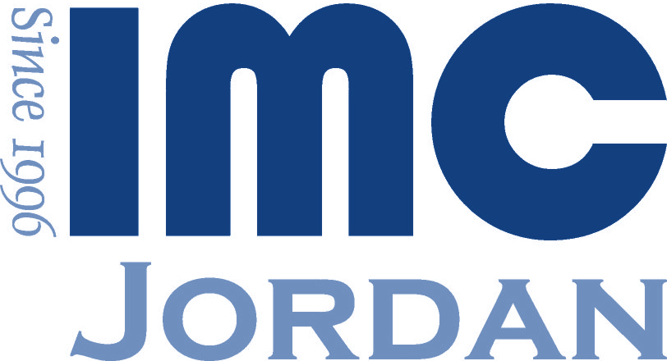 |  | Presents Management Consulting  “ A Workshop For Professionals”
Highlights
Management Consulting is a growing profession with a great impact on economy and society. This workshop deals with issues related to the organization and development of the management consulting skills. This workshop is a prerequisite for those who are interested in obtaining the worldwide respected Certified Management Consultant (CMC) designation.

Contents
- Introducing Consulting.
- Identifying & Marketing To Prospective Clients.
- Structuring & Marketing Proposals.
- Contracting & Agreements.
- Managing Client Engagements.
- Performing Client Engagements.
- Managing Clients Relationship.
- Communication.
- Ethical Issues.
- Other Issues.

Target Audience
- Management consultants.
- Those interested in obtaining the worldwide respected resignation.
- Members of IMC-Jordan.
- The business community members who are willing and would like to understand the management consulting profession.

Objectives
Empowering attendees with the knowledge and know-how, mainly the professionalism of the code of conduct, ethical standards and the development of one's skills, knowledge and behaviors through active participation in continuing professional development. Also, another main objective of the workshop is the preparation for the CMC designation.

Trainer Profile
To be decided
More Details
Workshop Language | Material – English, Presentation- Bi-Lingual
Duration | Four Days , 4:00PM – 8:00 pm , March 11-13 /2019
Venue | To Be Advised
Member Fees | JD 240
Non-Member Fees | JD 360
Last Date Registration | March 5th,2019
Tel: | 0779760678/065530856

